**Name: Nimya Satheesh**

**Roll No:26**

**Batch:B**

**Date:21-03-2022**

**NETWORKING & SYSTEM ADMINISTRATION LAB**

**Experiment No.: 1**

**Aim**

Install the latest version of Ubuntu on an Oracle VM VirtualBox.

**Procedure**

**Step 1:** [Download VirtualBox](https://www.virtualbox.org/wiki/Downloads) for Windows and install it on your computer

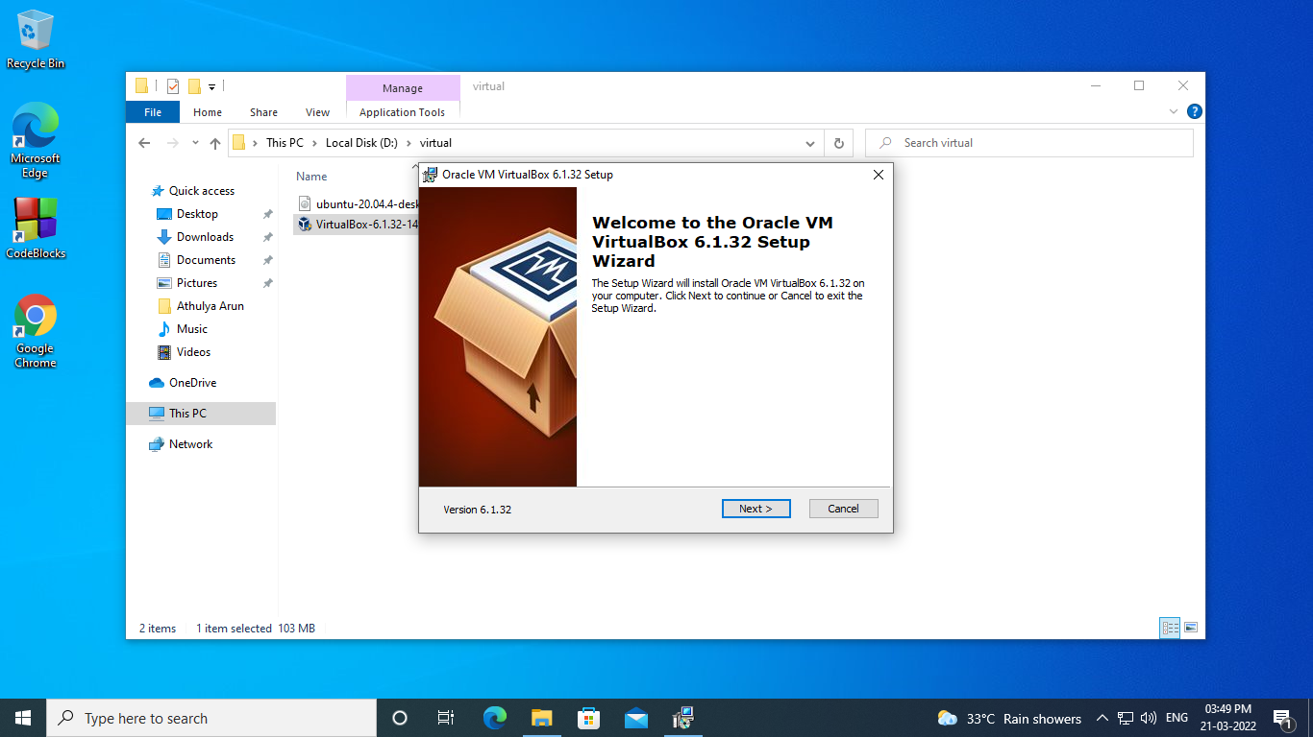

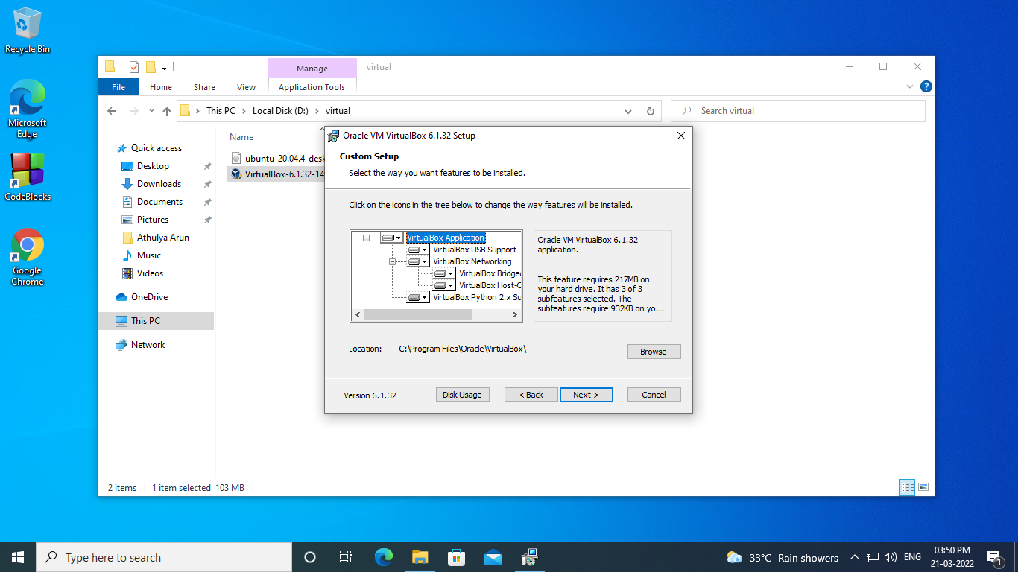

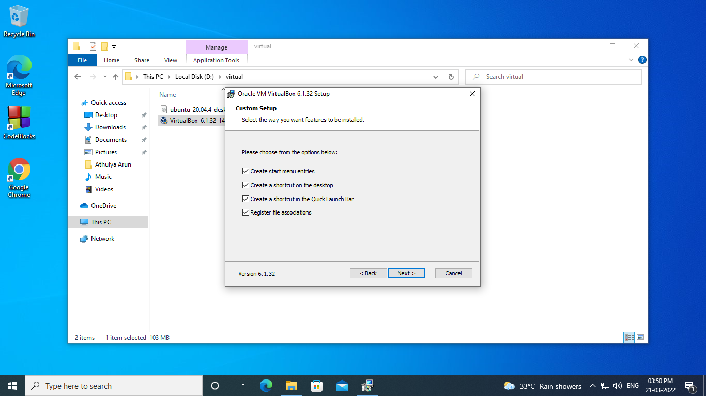

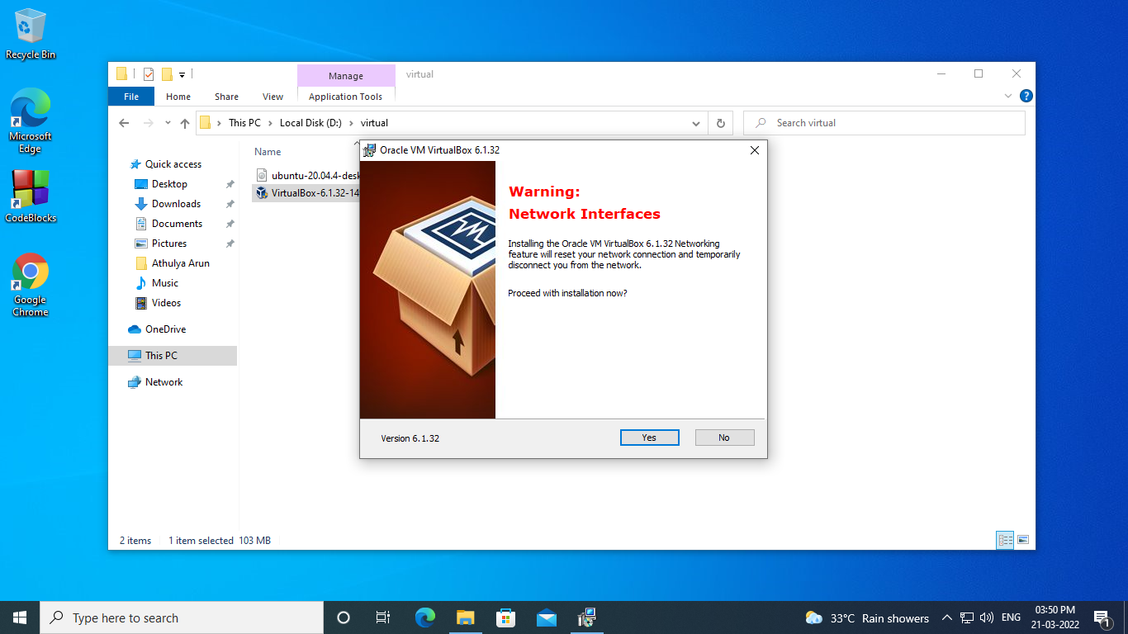

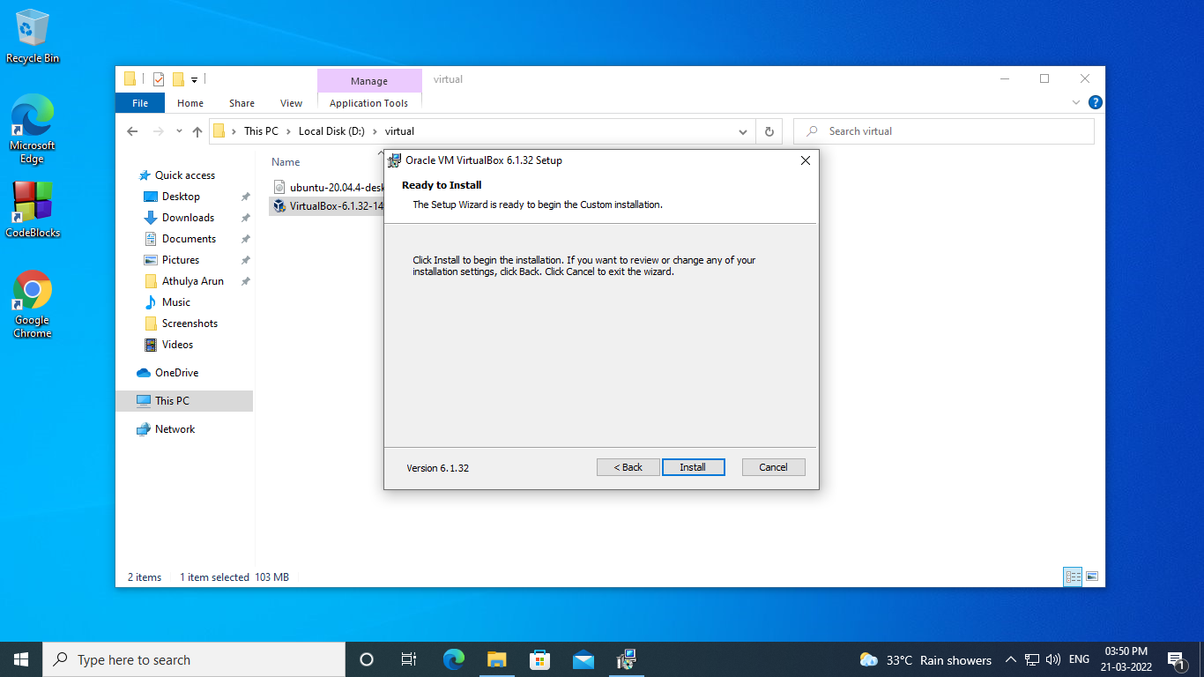

**Step 2:** Open VirtualBox and select New in the top taskbar.

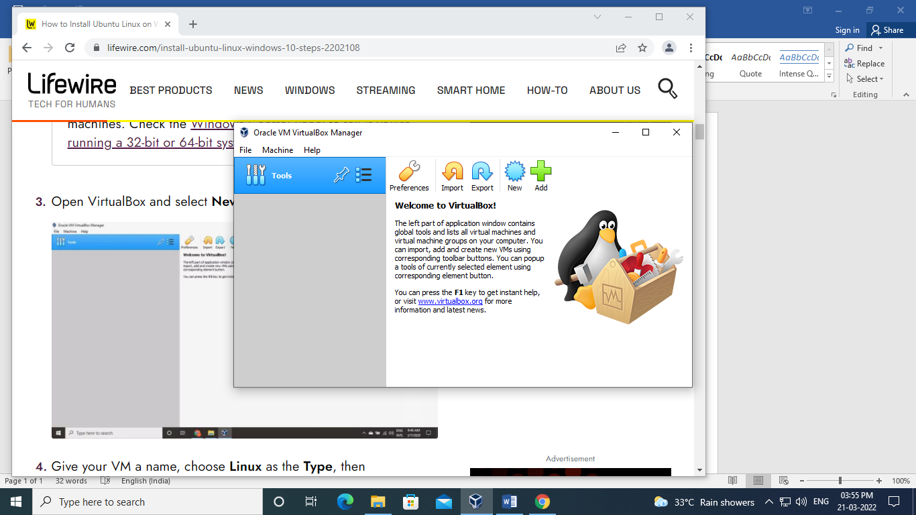

**Step 3:**Give your VM a name, choose Linux as the Type, then choose Ubuntu as the Version and select Next.

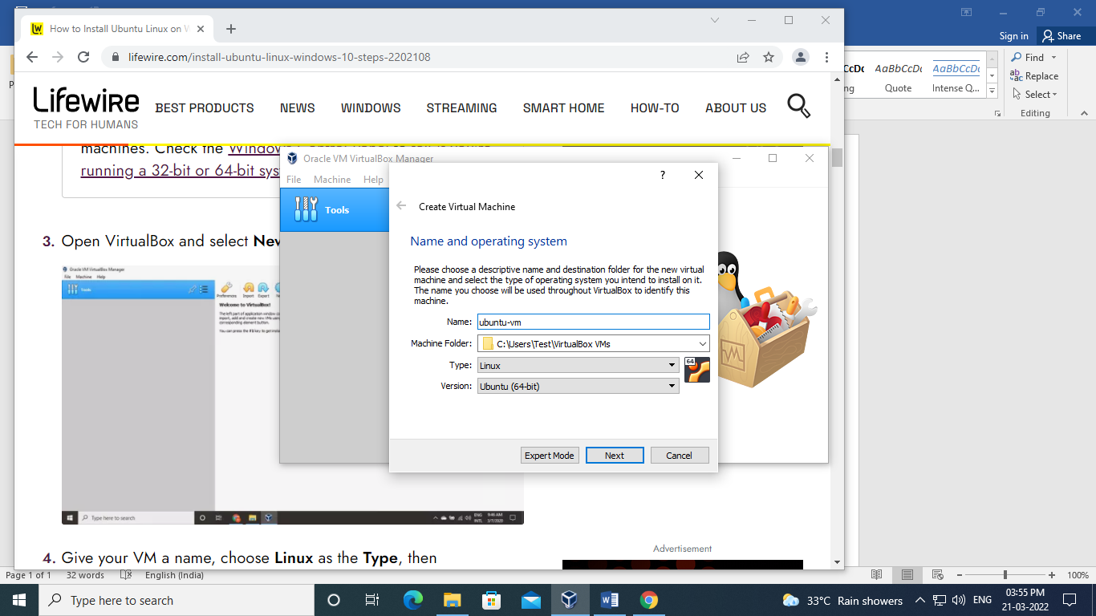

**Step 4:**Choose how much [RAM](https://www.lifewire.com/what-is-random-access-memory-ram-2618159) you want to assign to the virtual machine and select Next. The recommended minimum is 1024 [MB 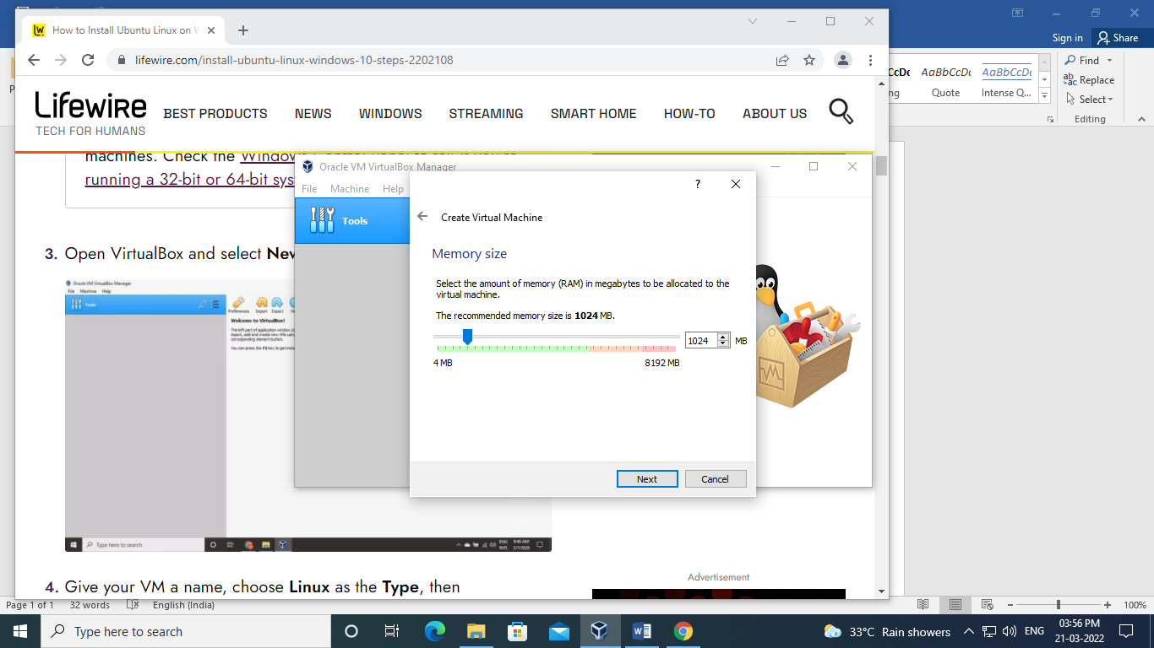](https://www.lifewire.com/what-is-a-megabit-2483412)

**Step 5:**Choose Create a virtual hard disk now and select Create.

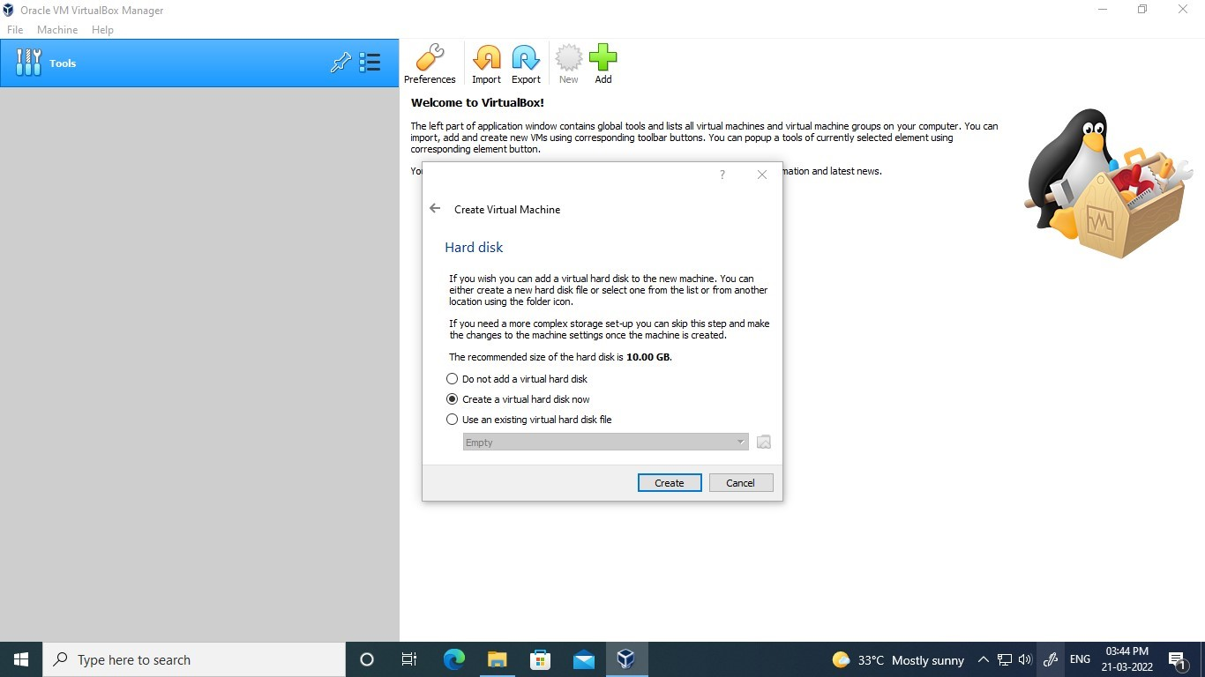

**Step 6:**Choose VDI (VirtualBox Disk Image) and select Next

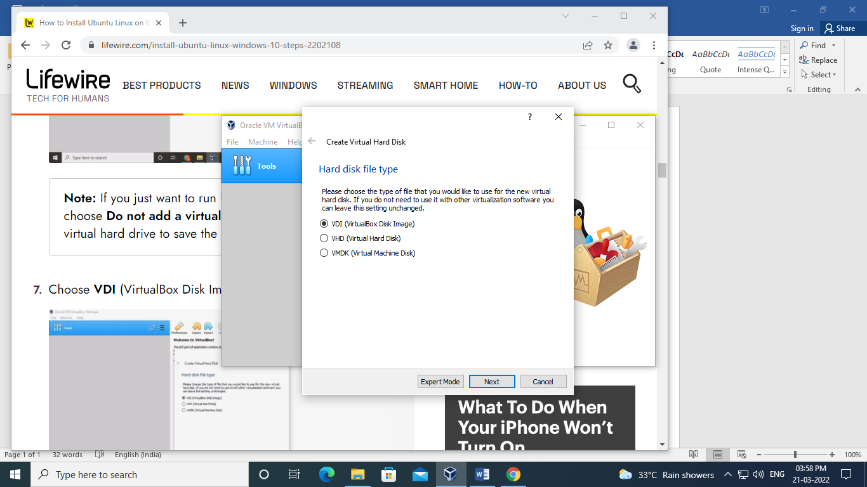

**Step 7:**Choose Dynamically allocated or Fixed size for the storage type and select Next.

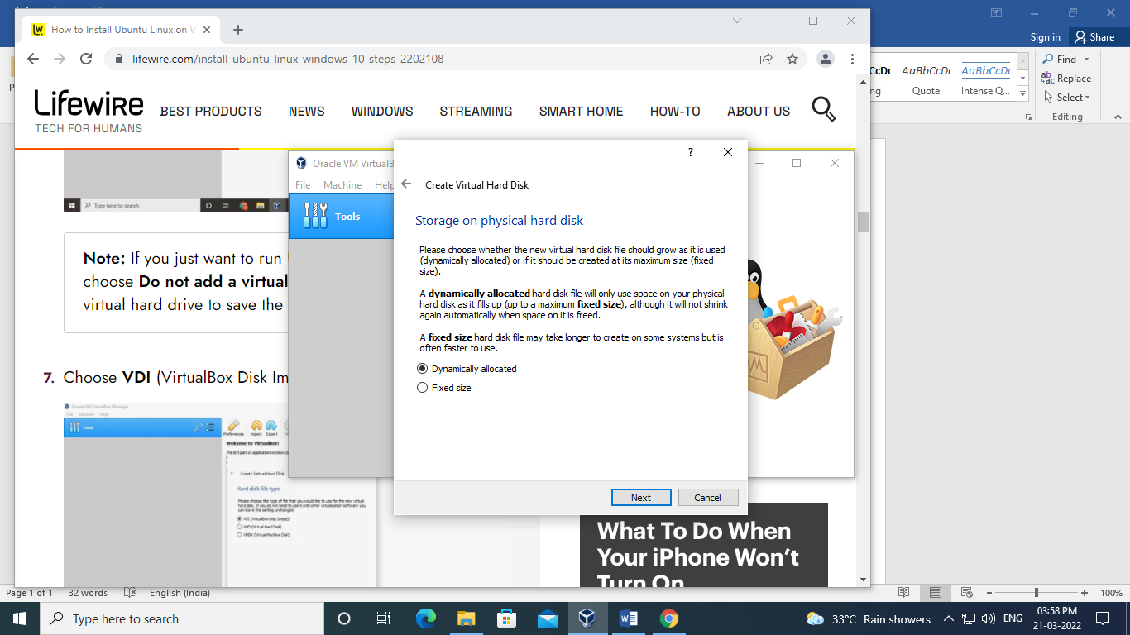

**Step 8:**Choose how much space you wish to set aside for Ubuntu and select Create.

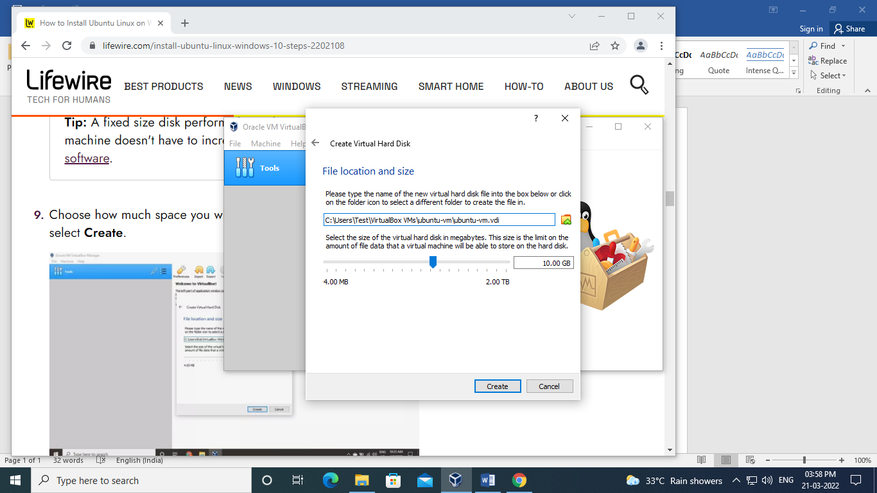

**Step 9:**The name of your virtual machine will now appear on the left side of the VirtualBox manager. Select Start in the toolbar to launch your VM.

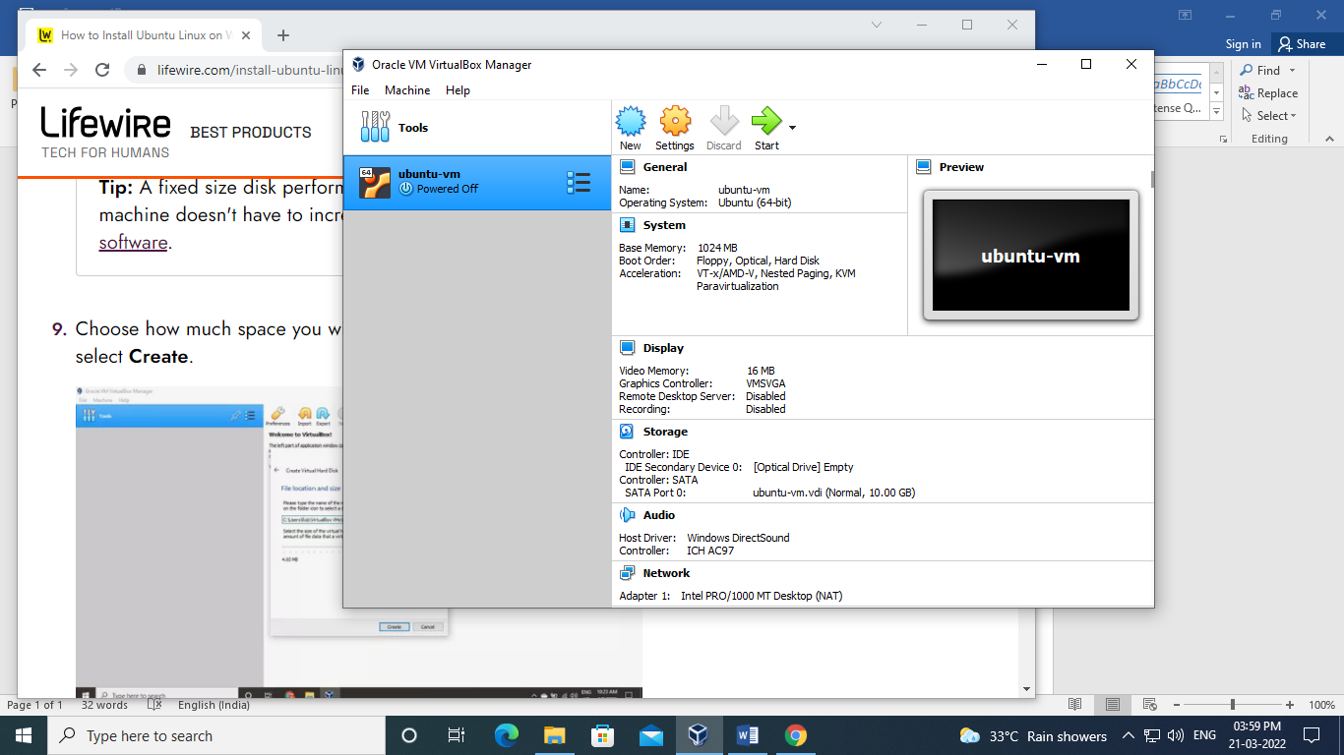

**Step 10:**This is the point where you need to choose the Ubuntu ISO file you downloaded earlier. If the VM doesn't automatically detect it, select the folder next to the Empty field.

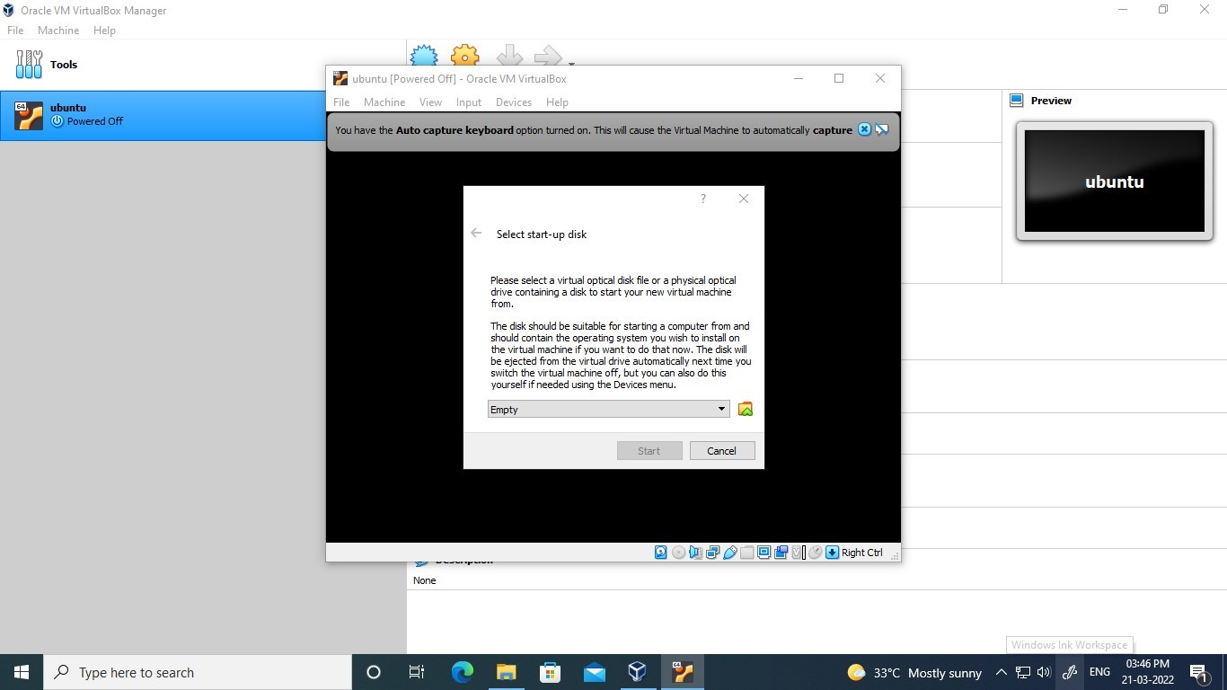

**Step 11:**Sett Up Ubuntu

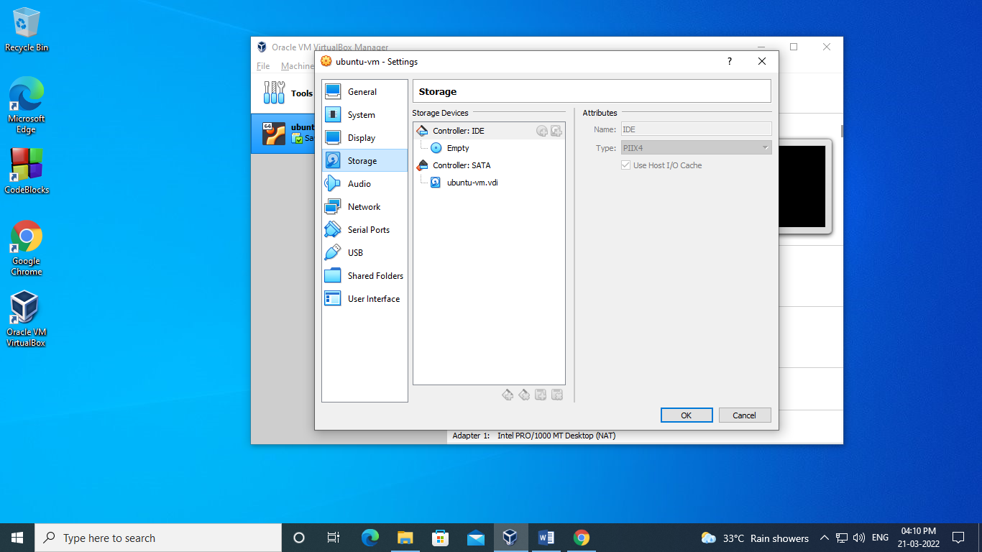

**Step 12:**Choose your Ubuntu disk image and select Open.

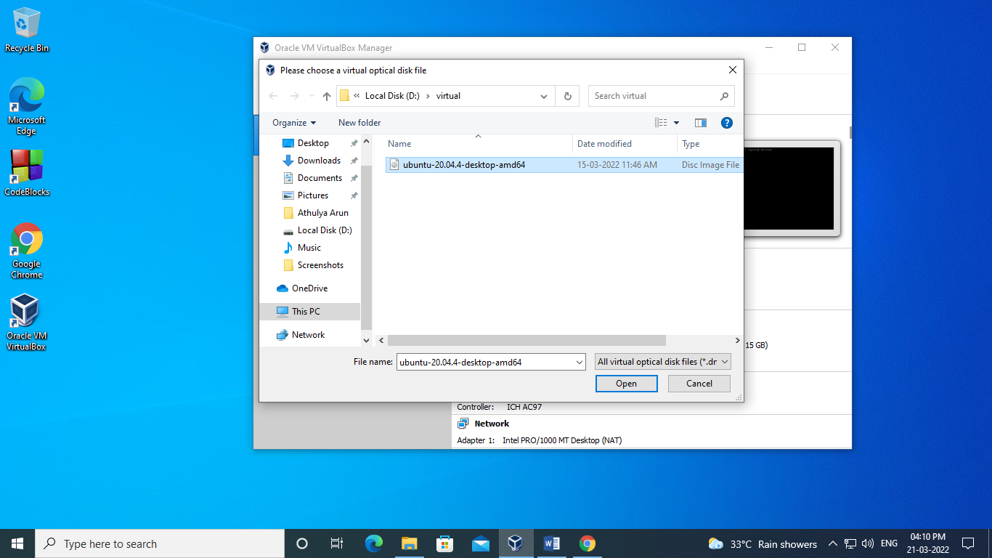

**Step 13:Y**our VM will now boot into a live version of Ubuntu. Choose your language and select Install Ubuntu.

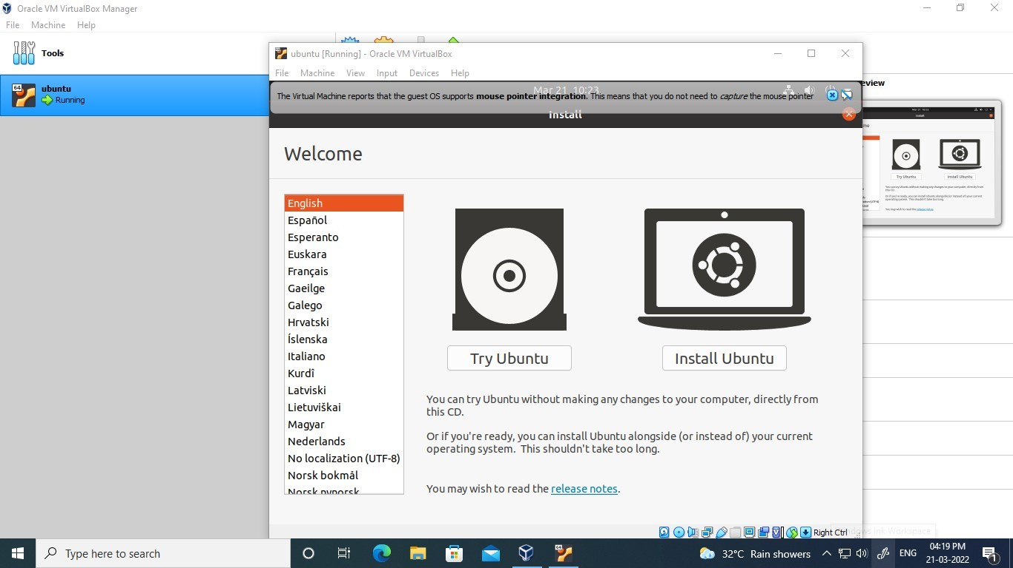

**Step 14:**Choose your keyboard layout and select Continue.

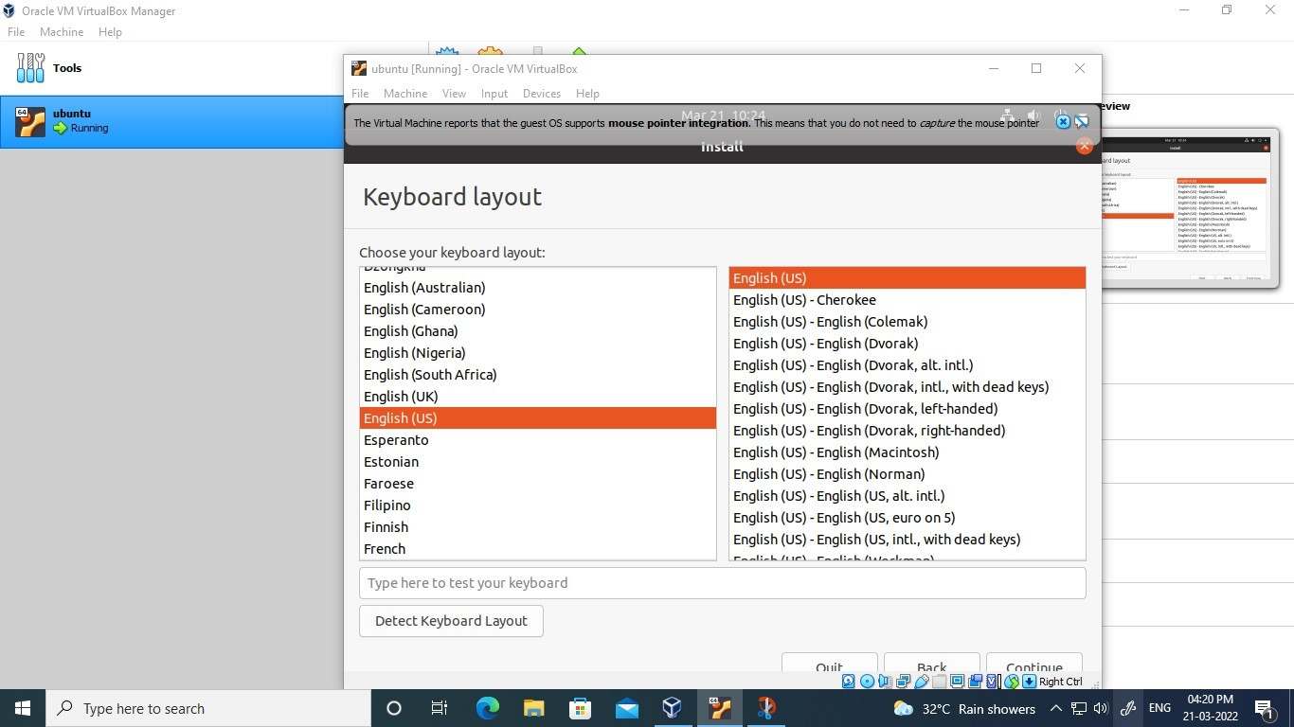

**Step 15:**Continue

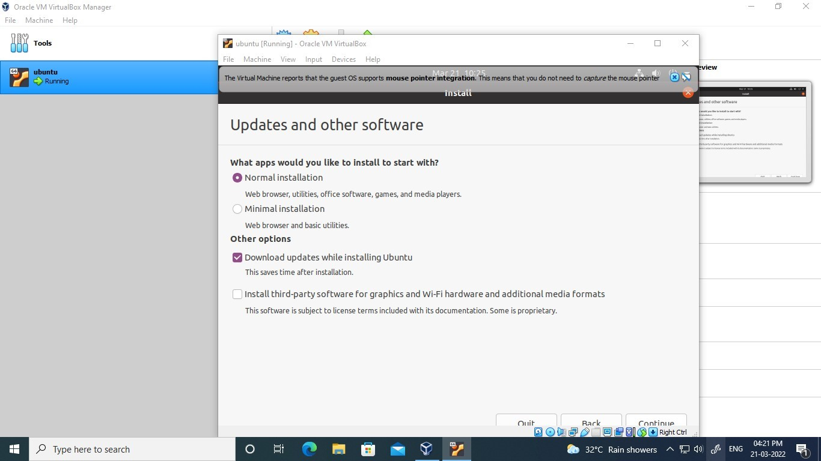

**Step 16:**Choose Erase disk and install Ubuntu and select Install Now, then select Continue to ignore the warning.

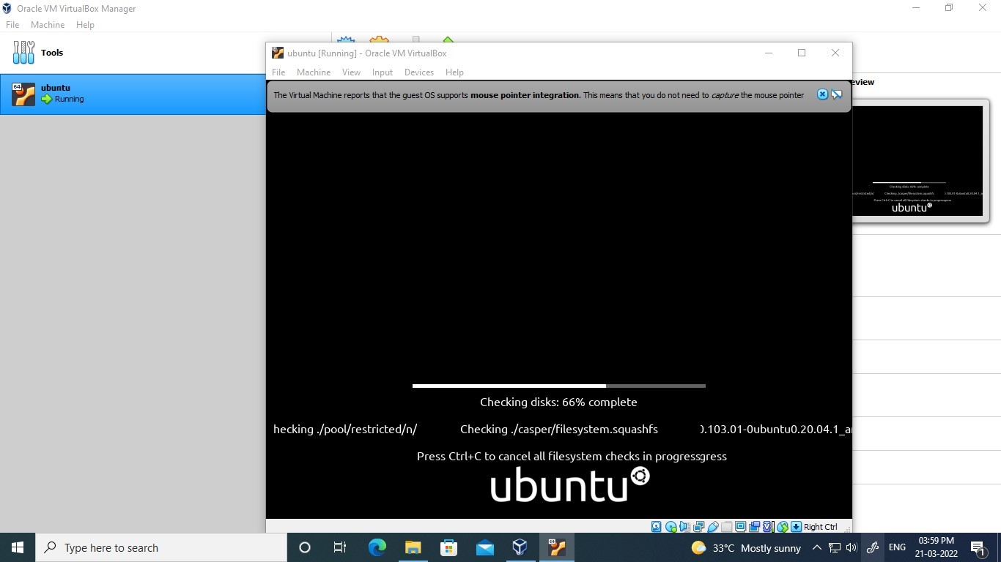

**Step 17:**Choose your time zone on the map, then select Continue.

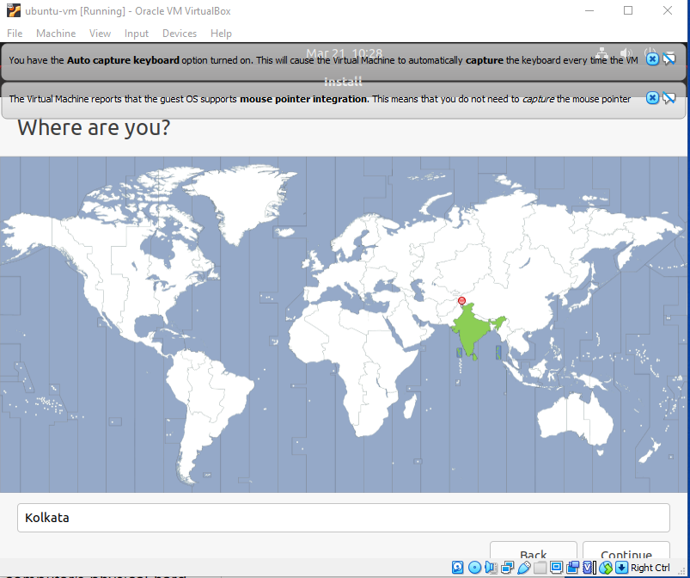

**Step 18:**Set up your user account and select Continue.

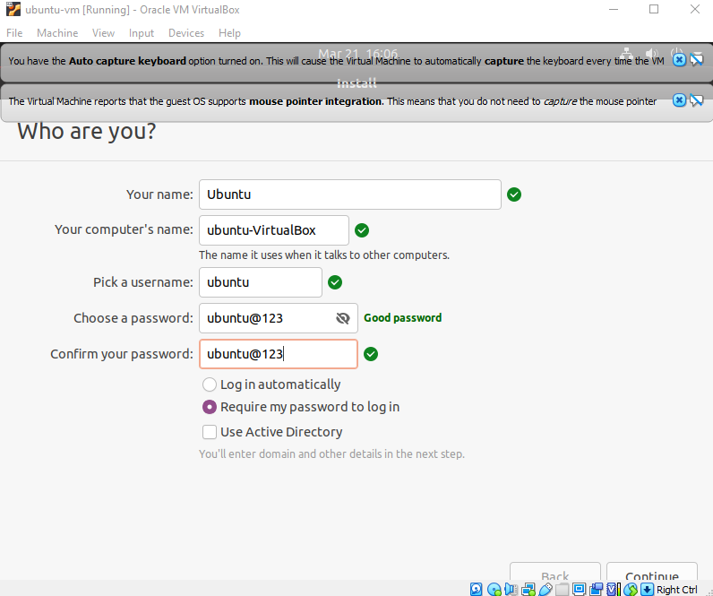

**Step 19:**Select Restart Now.

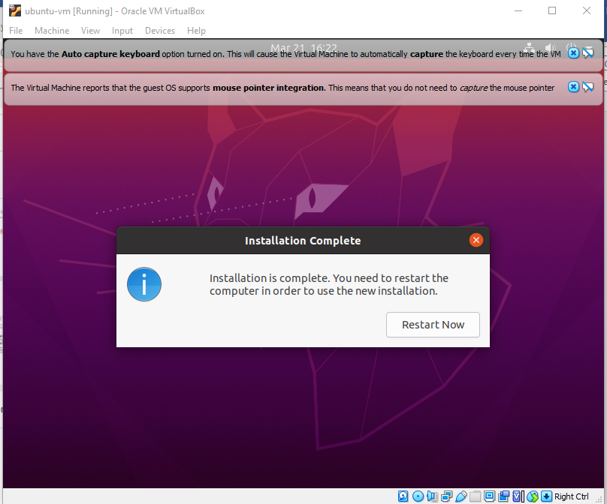

**Output Screenshot**

